**Tip Calculator**

**Topic: HTML & Javascript**

**Assignment Description** -  Your challenge is to build out this tip calculator app and get it looking as close to the design as possible.

* Calculate the correct tip and total cost of the bill per person

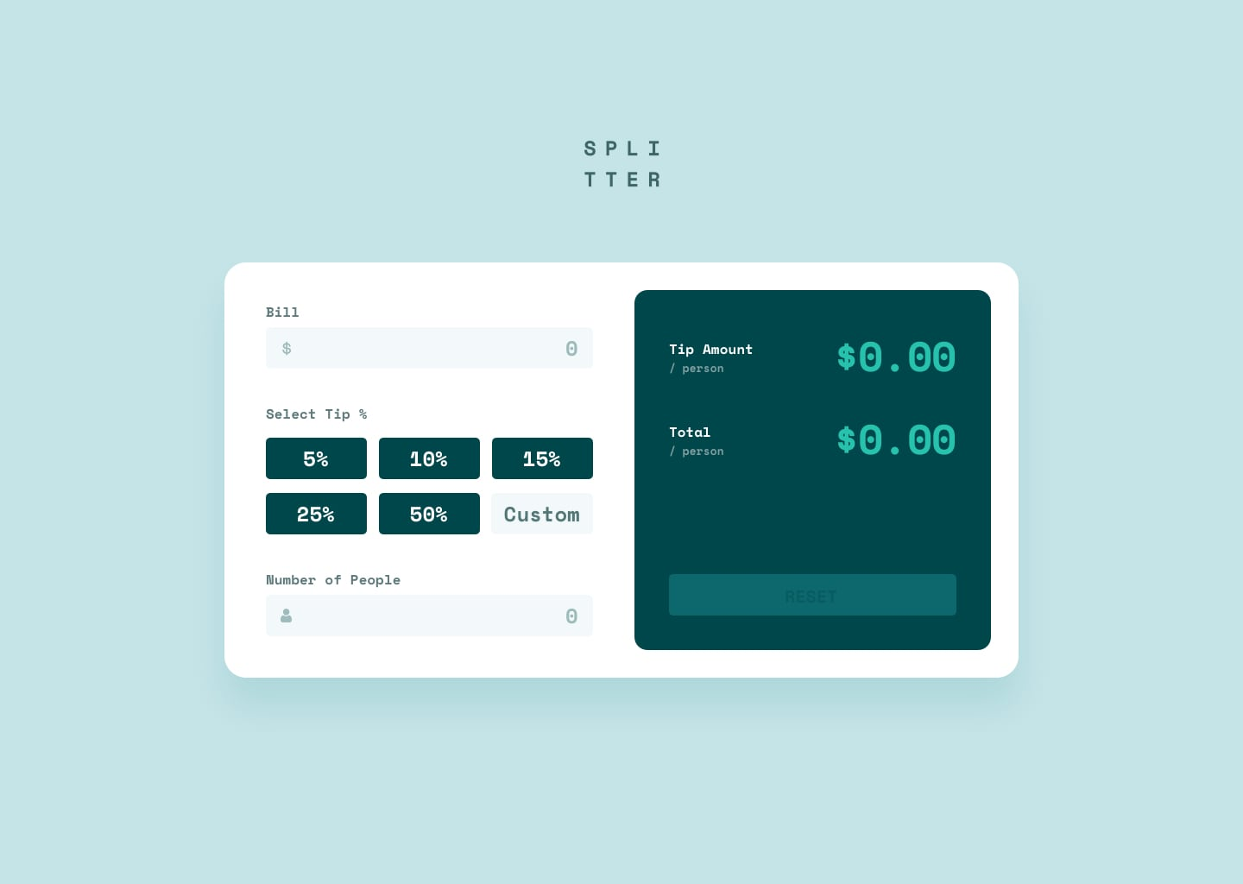

[Front-end Style Guide - tip calculator](https://docs.google.com/document/d/1Y57Qs9cLr2sqw6w8nwoQBv8iafKsedKbe59P26Y_aek/edit?usp=sharing)

**Note:**

* UI should not mandatory look like above pic. You may create your own UI or add some hovering or clicking effect. But functionality should be the same. (if you’re creating your own ui, make sure it looks better than above one)
* This is a **HTML/CSS, and JavaScript assignment**, and it should be done using these three languages.
* If you submit your assignment using ***ReactJS it’ll not be considered for evaluation***

**Test Cases**

|  |
| --- |
| Test Case 1 : Your Assignment Should contain all the following fields with same alignment and either same or better style  On the left hand side   * Bill input field * Select Tip   + With clickable options and blank custom input field * Number of people input field   On the right hand side   * Tip amount field, which will be automatically updated when the left-hand side input fields are entered * Total field, which will be automatically updated when the left-hand side input fields are entered. * Reset button   https://lh3.googleusercontent.com/6_8GZRFRjvnOG0g8GWOlb6JQ4rEny1IP22sGQPuErJtky7SBAFjCACbIyoGRGU3ie6uD-A69pjQhhwvtSin9Y_xIgWB9x4gL4_sgR2K79LNSEBriljgtHs2UXDULh7_uDl0TSuKk2f4V_oLUiBw3hY-uIuKndrkRyljMh8qgSJs0Iiwi4EftqNMVO89XKg |
| Test Case 2: We should only be able to enter numbers in each input field |
| Test Case 3 : when user fills all input fields the **tip amount** should be automatically be updated  https://lh5.googleusercontent.com/K5VhZu9zrC929zWyfyB7symtZhnMFcFtZT-UHu4at4lGe7B6EyGGQd1OXx0JoGwiUpRdVjn3aZmNXw6cQLbOCaG9P_hjXvSSp1RDrGtHGqWL7gyNa2pcvZZnLD7Gtjg15EvUIEGkCGaxItUV7mujS0ZqTc7gD3Fj4dVyfGU-8gIH3d3vBJxRE5s_ZEjj3g  Note : if user didn’t attempt fill any field then tip should not be calculate  **Tip Amount** can be be calculate using following formula  ⇒ | **(Bill amount * tip value / 100) / Number of people** | |
| Test Case 4 : when user fills all input fields the **Total** should be automatically be updated  https://lh5.googleusercontent.com/K5VhZu9zrC929zWyfyB7symtZhnMFcFtZT-UHu4at4lGe7B6EyGGQd1OXx0JoGwiUpRdVjn3aZmNXw6cQLbOCaG9P_hjXvSSp1RDrGtHGqWL7gyNa2pcvZZnLD7Gtjg15EvUIEGkCGaxItUV7mujS0ZqTc7gD3Fj4dVyfGU-8gIH3d3vBJxRE5s_ZEjj3g  Note : if user didn’t attempt fill any field then tip should not be calculate  **Tip Amount** can be be calculate using following formula  ⇒ | **Bill amount + (Bill amount * tip value / 100) / Number of people** | |
| Test Case 5 : When user clicks reset button, all the all the input fields should be emptied and Tip amount and Total should be reset to 0  https://lh3.googleusercontent.com/5J3BTbJ4DVel2LO-HhPT2cFjBmFCE_5-bf757uW-8DVtkdcK3rIQWIF_1xvmH-7aboL9VF3M6YbZSKXDAoWzIoNHA4VgSUWSfwtCQ5XVNmSM99kvBcVTRD8p0eLovAcvCXG30XNZGIkmVr6iIiIM2yPmfAErd1JJyiAAPUVIg4K2gQmuMFmK04kRauDFyw |

**Submission Steps:**

1. Create a folder named `tip_calculator_assignment`
2. `Age_Calculator_assignment` should contain three folders
   1. Html/css files
   2. Javascript file
   3. Image folder containing Screenshot of final output
3. Compress your folder to zip file and submit it

You can use the document below as a guide to learn [how to zip a folder](https://docs.google.com/document/d/1wLV5j5eNMfY5GQ05R6ApCdqOEkb-1gbIALb3QYEWLJk/edit?usp=sharing) and [how to submit in a feedback form](https://docs.google.com/document/d/1wLV5j5eNMfY5GQ05R6ApCdqOEkb-1gbIALb3QYEWLJk/edit?usp=sharing) : [Steps for submitting in a Feedback Form](https://docs.google.com/document/d/1wLV5j5eNMfY5GQ05R6ApCdqOEkb-1gbIALb3QYEWLJk/edit?usp=sharing)